**TUGAS PRATIKUM 3**

**WEB PROGRAMMING 2**



Disusun Oleh :

Nama : Azam Putra Imanto

NIM : 18090011

Kelas : 5C

Prodi : DIV Teknik Informatika

Dosen : Dwi Intan Af'idah, M.Kom.

k

**DIV TEKNIK INFORMATIKA**

**POLITEKNIK HARAPAN BERSAMA TEGAL**

**2020**

1. **Source Code**

Matakuliah.php 🡪 application/controllers

view-form-matakuliah.php 🡪 application/views

view-data-matakuliah.php 🡪 application/views

1. **URL**

[http://localhost/pustaka_booking_azam/Matakuliah](http://localhost/pustaka_booking_azam/index.php/Matakuliah)

<http://localhost/pustaka_booking_azam/Matakuliah/cetak>

1. **Capture Hasil**

Folmulir

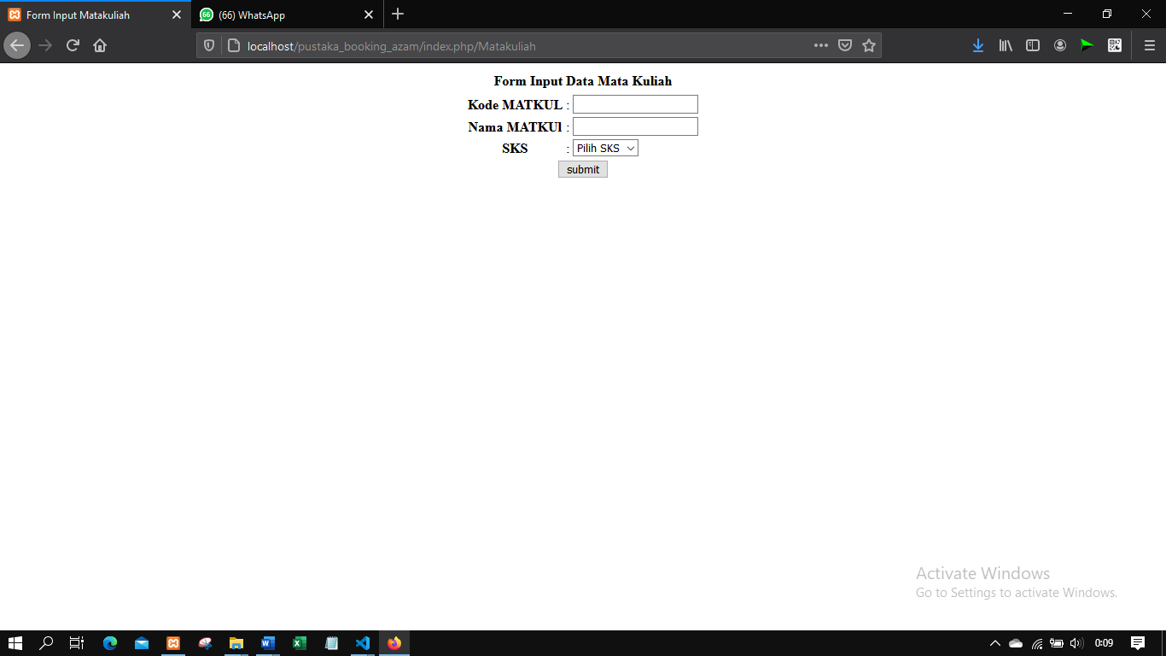

Cetak Folmulir

